Relational Database Project Proposal

Group Members: Federico Balestri, Nicola Barsanti, Riccardo Bertini, Mirco Quintavalla

Introduction

Our proposal for an application based on a relational database consists in the development of a software designed to meet the data management requirements of a fictional tech company named *Innovative Solutions*, whose core business is the assembly of electronic and mechanical components into consumer-grade products (e.g. remotes or smart light bulbs).

Working Hypotheses

The design of the relational database will be based upon the following working hypotheses:

* *Customers* may purchase any *Products* up to their available quantity
* Each *Employee* in the company may belong to up to one *Team*
* *Teams* are assigned to the assembly of the *Products* offered by the company, where each Product is assembled by a single team
* *Products* are composed of one or more *Components*
* *Components* are purchased from a list of *Suppliers*, where different suppliers may offer the same component at different prices

Software Architecture

The application will consist in a front-end module written in Java which through a command-line interface allows the company’s system administrators to connect and perform a list of predefined and parametrized operations upon an underlying MySQL database.

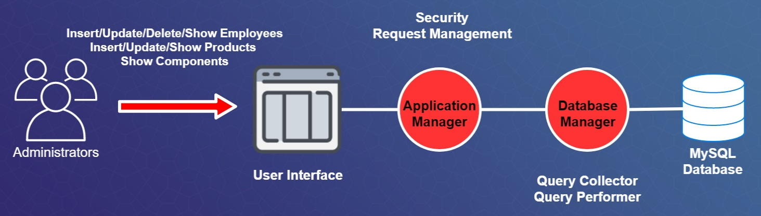

Software Functionalities

Through the use of the command-line interface, the system administrators will be able to perform the following operations on the database:

* Set or change the Team an Employee belongs to
* Insert a new Employee
* Insert a new Product
* Delete an Employee
* Delete a Team
* Show the currently available Products
* Show the currently available Components
* Edit a Product’s information

Application Dataflow

The dataflow in the application appears as follows:

